

*Entertainer Data Analysis*

***Low Level Design***

***Authors:***

***Abhijeet Sethy***

***Sandeep Kumar Sahoo***



**DOCUMENT CONTROL:**

|  |  |  |
| --- | --- | --- |
| **VERSION** | **DATE** | **COMMENTS** |
| 0.1 | 23- Dec - 2022 | Introduction and architecture defined |
| 0.2 | 24 - Dec - 2022 | Architecture & Architecture description appended and updated. |
| 0.3 | 02 - Jan - 2022 | Data cleaning MS Excel 2019 |
| 0.4 | 11 – Feb - 2023 | Data visualization using Power BI |



**Contents**

Introduction 4

1. Architecture 5

2. Data Description 6

4. Data Visualization 8



# Introduction

## The information being discussed refers to analysis of performers. The examination of entertainment industry statistics and each performer's performance is the major goal. The performance includes the total number of awards won, including nominations for their various professions, as well as the awards received in each sector, such as Oscar, Emmy, Grammy, etc.

## Scope

The primary goal of the study was to identify the top entertainers based on the number of nominations and awards they have received over their careers so far.



## Architecture

The following is a picture of the project's whole architecture



* Our entire data source is in our excel file. Data can be shown and accessed for a better understanding of the dataset; several outliers were eliminated by several operations.
* After that, the dataset was imported to Power BI and the dataset was uploaded.
* The functionalities show the result according to query was entered by the end user or client.
* Client entered the query to show the graph, after selecting the data in form of rows and columns. In POWER BI, it was understood the query and generated the best recommended charts based on selected data and was returned into the POWER BI screen.
* Various charts and dashboard (screen) were prepared which can be accessed by the client.



## Data Description

* Three data files in csv format were provided.
* At first the data set was converted to readable csv format.

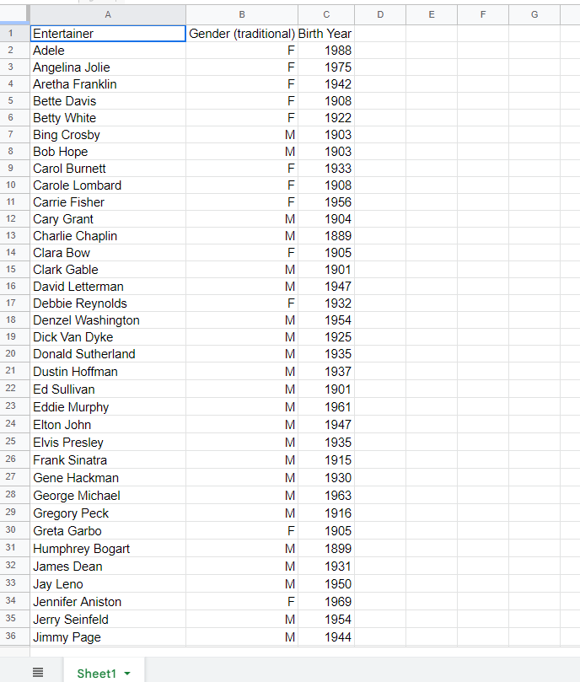 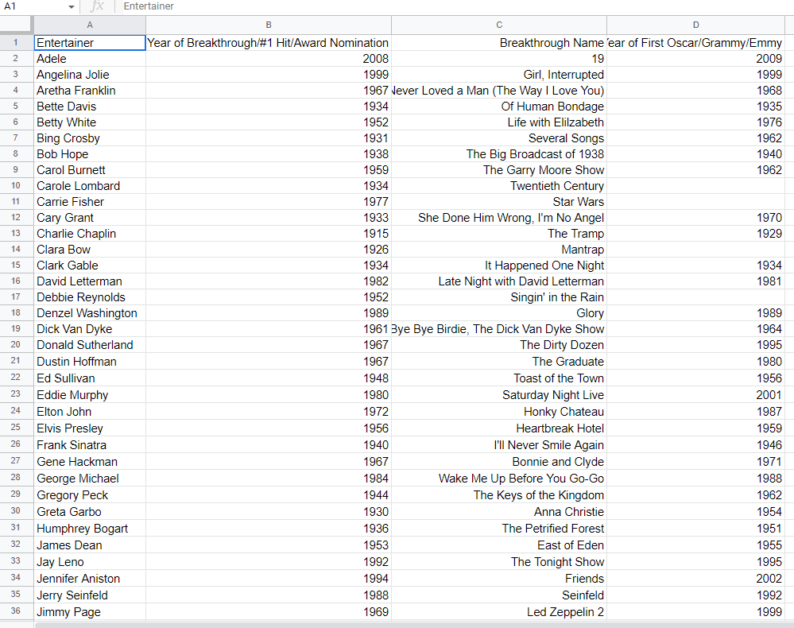

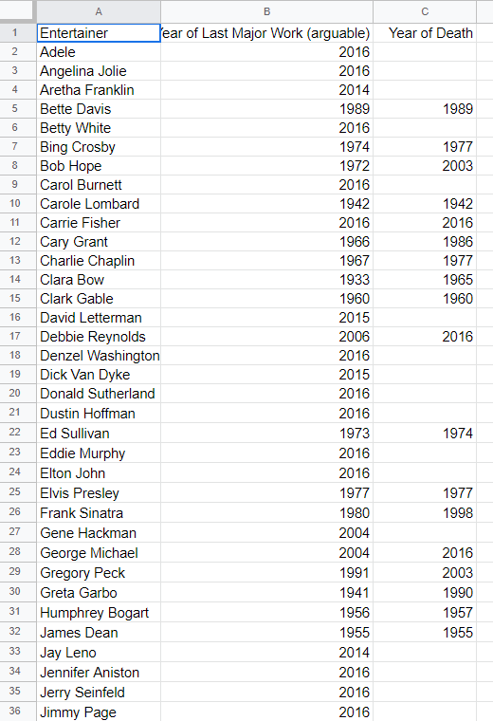

(Datasets)

* 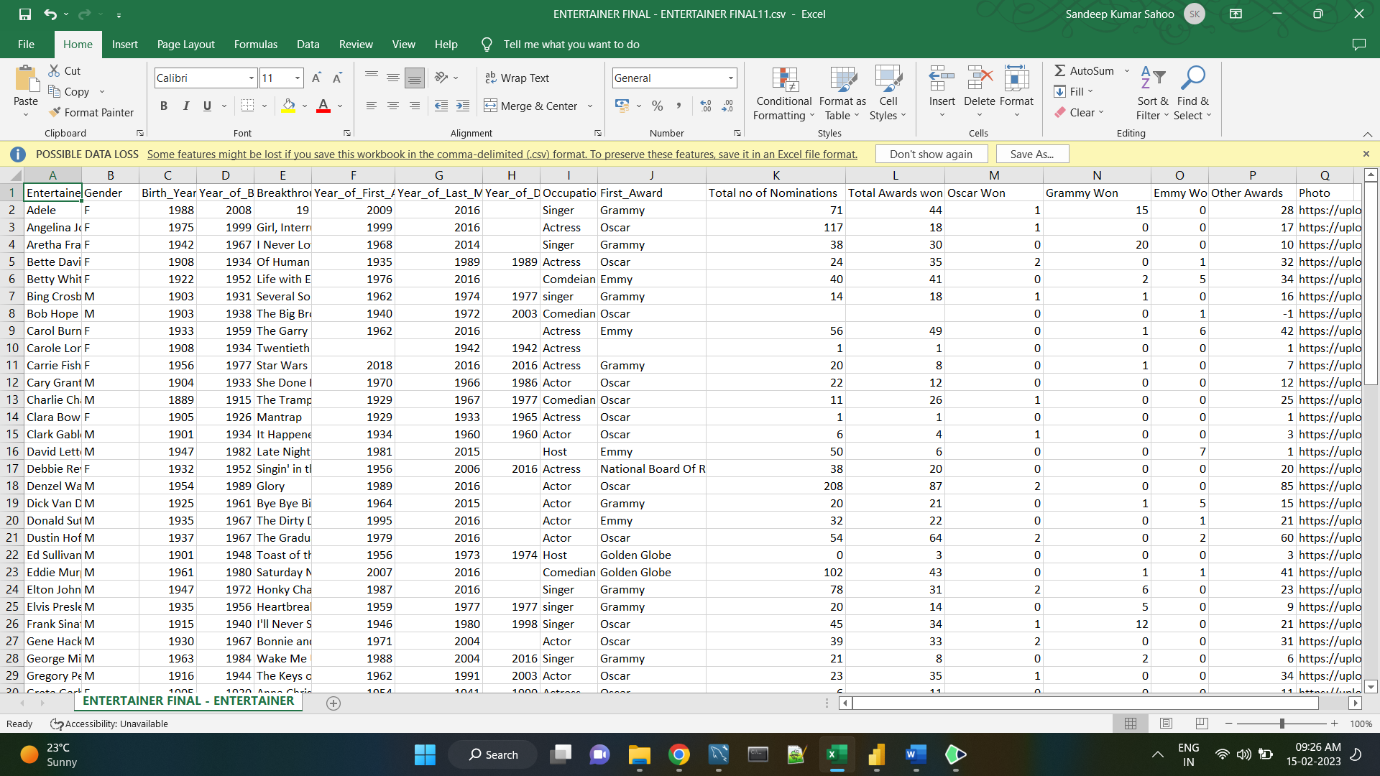 A few columns were added to the dataset to meet the needs of the graphs. In Excel, basic columns with information like Grammy wins, Emmy wins, Oscar wins, and photos were added.
* The dataset was imported to POWER BI which was created as shown below

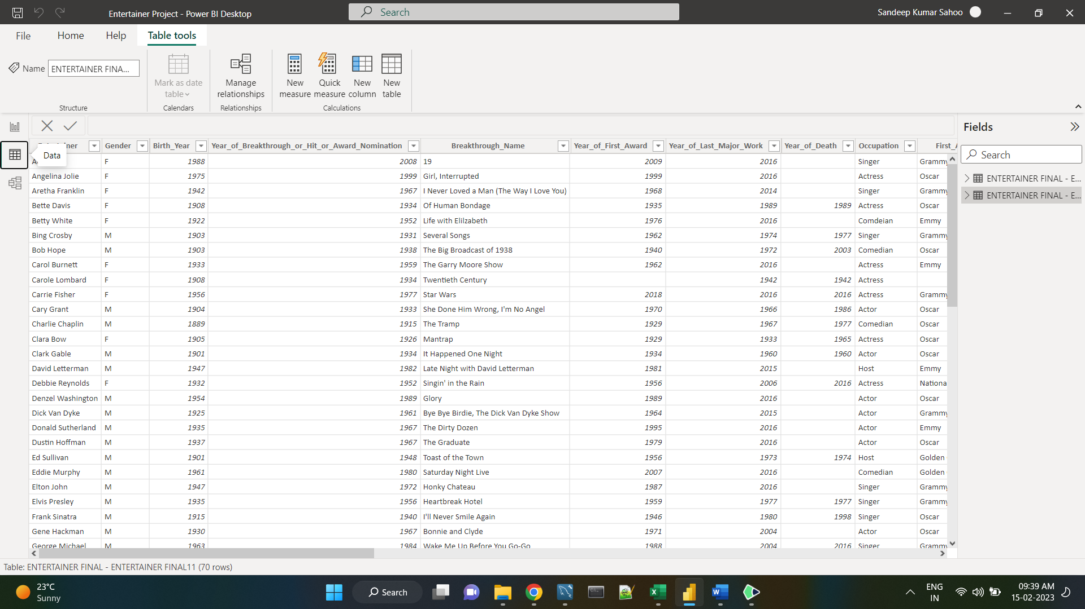.





## Data Visualization

* After performing all the data filtration part, the file was imported to POWER BI so that different charts and dashboard can be made using the desired form of data.

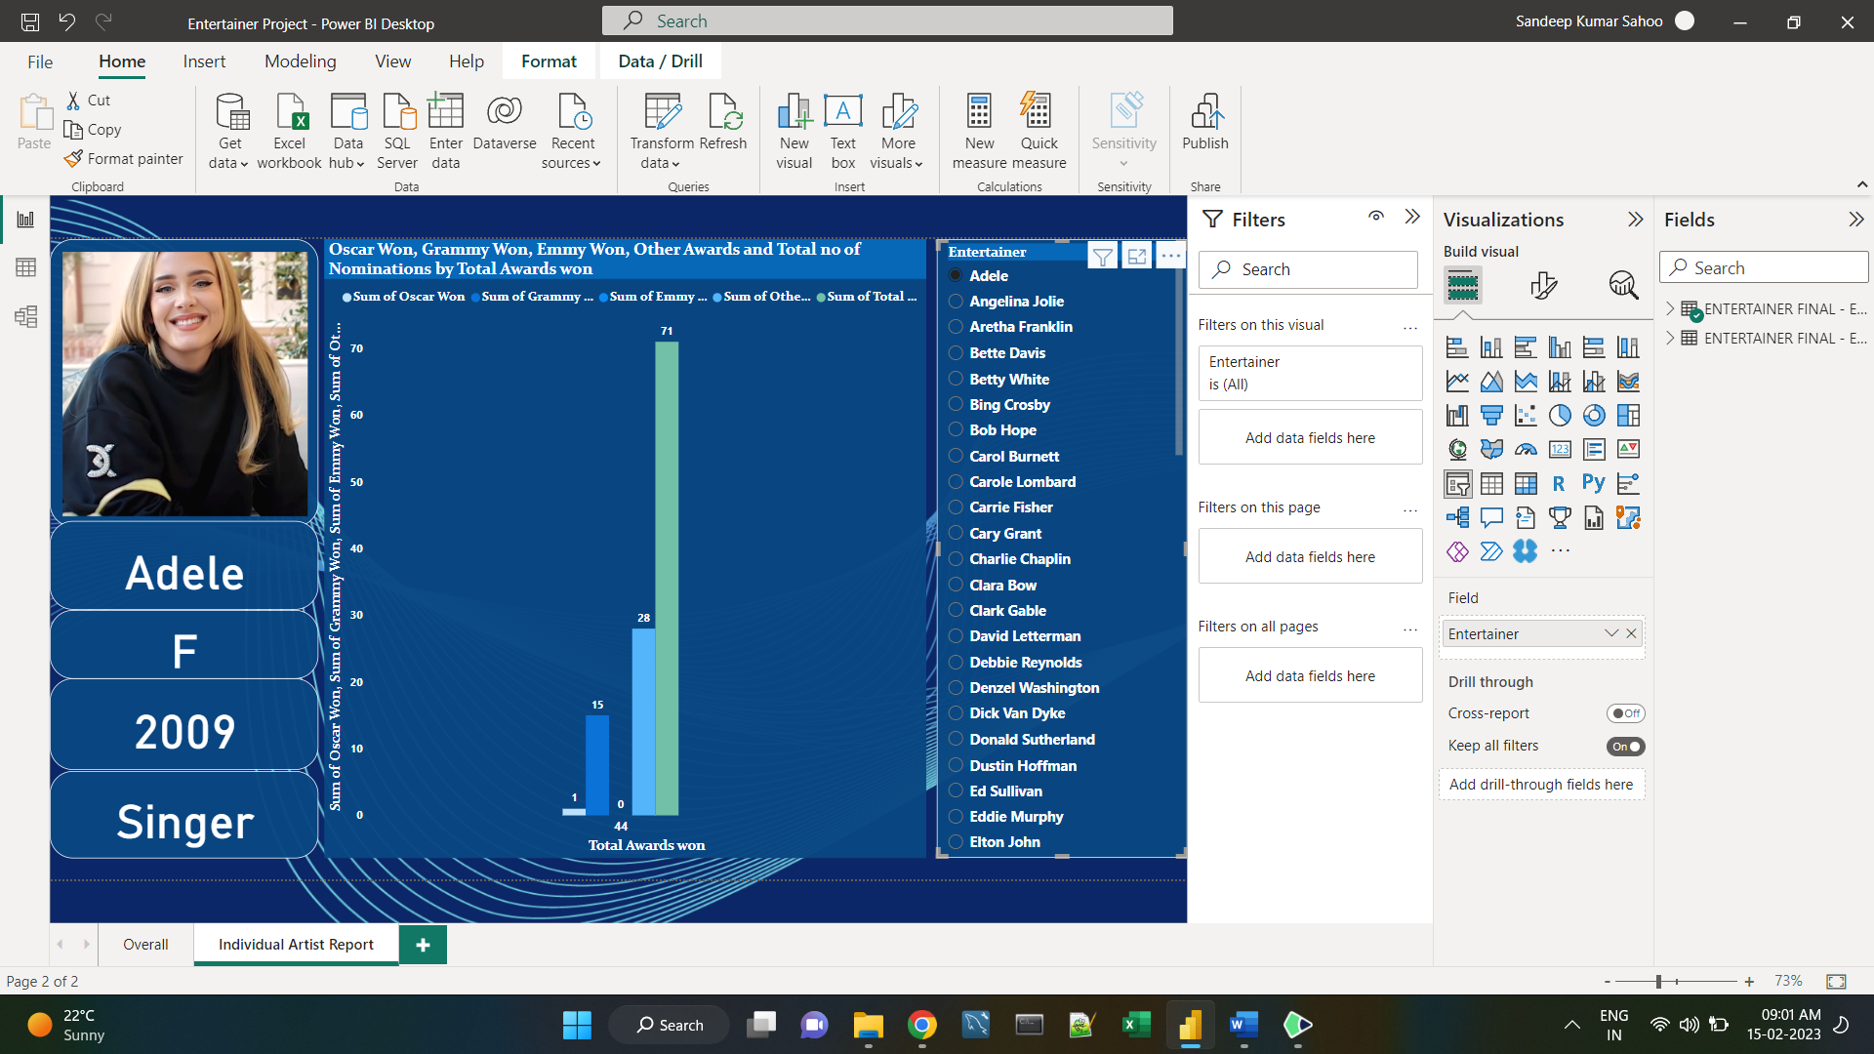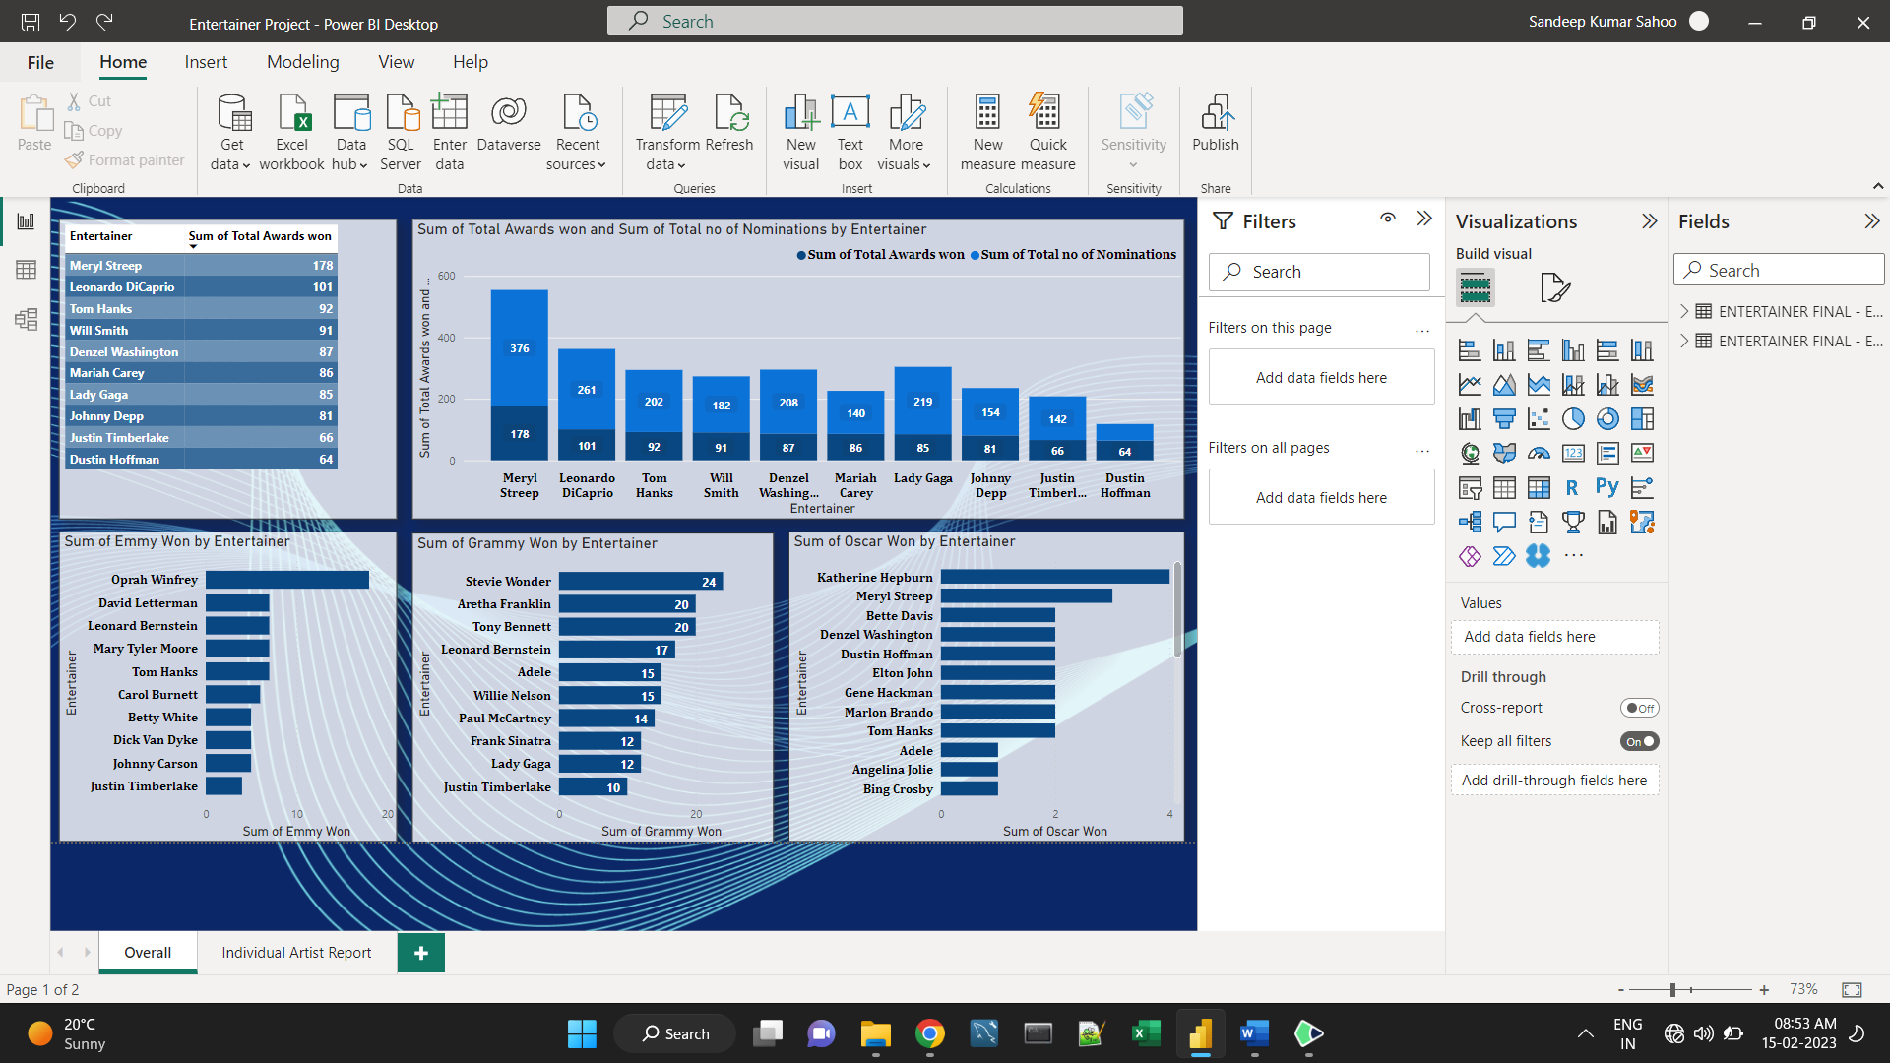

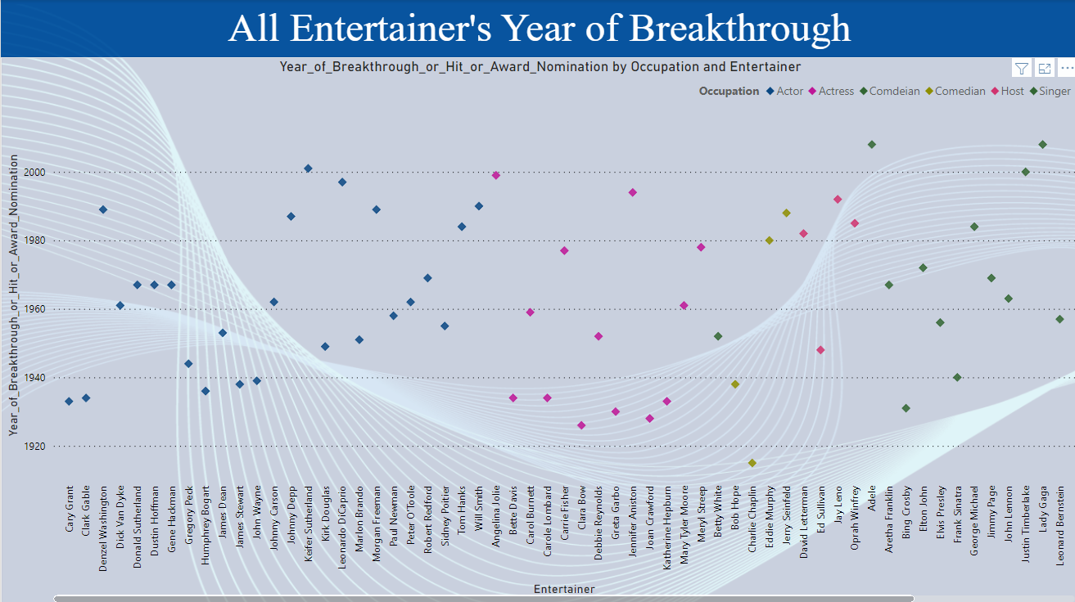

* The final report is published in Power BI service. Then the link is shared to client. Below is the document link to access the report.
* **Link:** https://app.powerbi.com/view?r=eyJrIjoiYzkxNzc5NTItNmM2OC00MWRhLWExYWEtZGY1ZGMzNjAyMTc4IiwidCI6IjFlODI2NjA0LWQ0Y2QtNGUyYi04MWQ1LWVkYzRjZDJiYjFiOSJ9
* Also the entire project is uploaded in Novypro.com for public use.
* **Link**: https://www.novypro.com/project/pbix
* The report must be published in the power service following the creation of the graphs.
* 